**SQL queries**

Coffee shop sales project

Basic conversions as per the data.

create database coffee_shop_sales;

After creating the database, the csv file is imported using table data import wizard.

use coffee_shop_sales;

select * from coffee_shop_sales;

describe coffee_shop_sales;

we observe the transaction_date and transaction_time are in text format which should be converted to date format.

Changing the data type and conversions of the table:

update coffee_shop_sales set transaction_date = str_to_date(transaction_date, '%d/%m/%Y');

alter table coffee_shop_sales modify column transaction_date date;

The code first updates the transaction_date entries in the coffee_shop_sales table from a string format to a DATE format using the STR_TO_DATE function. Then, it modifies the transaction_date column to have the DATE data type, ensuring that future entries will be stored in the correct format.

update coffee_shop_sales set transaction_time = str_to_date(transaction_time, '%H:%i:%s');

alter table coffee_shop_sales modify column transaction_time time;

The code first updates the transaction_time entries in the coffee_shop_sales table from a string format to a TIME format using the STR_TO_DATE function. Then, it modifies the transaction_time column to have the TIME data type, ensuring that future entries will be stored in the correct format.

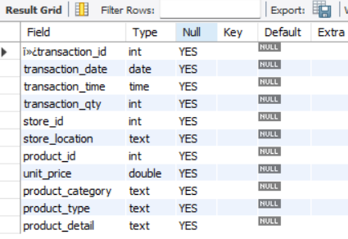

alter table coffee_shop_sales change column ï»¿transaction_id transaction_id int;

*There are some symbols at the beginning of transaction_id name, we alter that to transaction_id using the above statement.*

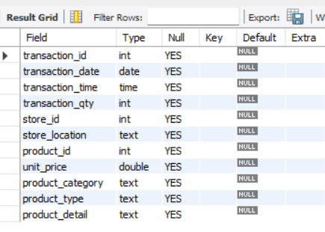

**Sales analysis:**

**calculate the total sales for each respective month:**

select month(transaction_date), round(sum(transaction_qty * unit_price),0) as total_sales

from coffee_shop_sales group by month(transaction_date)

order by month(transaction_date);

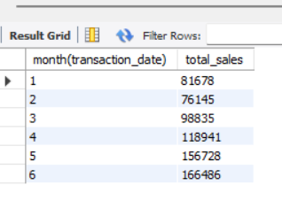

**calculate the total sales for any particular given month:**

select month(transaction_date), round(sum(transaction_qty * unit_price),0) as total_sales

from coffee_shop_sales where month(transaction_date) = 5 group by month(transaction_date);

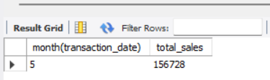

**Determine the month-on-month sales increase or decrease in sales:**

**calculate the difference in sales between the selected month and the previous month:**

select month(transaction_date) as month,

sum(transaction_qty * unit_price) as total_sales,

lag(sum(transaction_qty * unit_price)) over (order by month(transaction_date)) as previous_sales,

sum(transaction_qty * unit_price) - lag(sum(transaction_qty * unit_price)) over (order by month(transaction_date)) as difference_in_sales,

case

when sum(transaction_qty * unit_price) > lag(sum(transaction_qty * unit_price)) over(order by month(transaction_date)) then ' increase in sales'

when sum(transaction_qty * unit_price) < lag(sum(transaction_qty * unit_price)) over(order by month(transaction_date)) then 'decrease in sales'

when sum(transaction_qty * unit_price) = lag(sum(transaction_qty * unit_price)) over(order by month(transaction_date)) then 'no profit no loss'

end sales_distribution

from coffee_shop_sales where month(transaction_date)

group by month(transaction_date)

order by month(transaction_date);

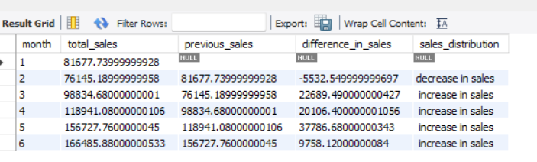

**Order analysis:**

**calculate the total number of orders for each respective month:**

select month(transaction_date), count(transaction_id) as total_orders from coffee_shop_sales

group by month(transaction_date) order by month(transaction_date);

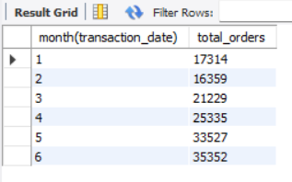

**calculate the total orders for any particular given month:**

select month(transaction_date), count(transaction_id) as total_orders from coffee_shop_sales where month(transaction_date) = 4

group by month(transaction_date);

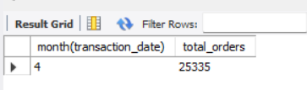

**Determine the month-on-month sales increase or decrease in the number of orders:**

**calculate the difference in the number of orders between the selected month and the previous month:**

select month(transaction_date) as month_no, count(transaction_id) as current_month_orders,

lag(count(transaction_id)) over(order by month(transaction_date)) as previous_month_orders,

count(transaction_id) - lag(count(transaction_id)) over(order by month(transaction_date)) as difference_in_orders,

case

when count(transaction_id) > lag(count(transaction_id)) over(order by month(transaction_date)) then 'increase in orders'

when count(transaction_id) < lag(count(transaction_id)) over(order by month(transaction_date)) then 'decrease in orders'

when count(transaction_id)=lag(count(transaction_id)) over(order by month(transaction_date)) then 'same orders'

end order_distribution

from coffee_shop_sales group by month(transaction_date) order by month(transaction_date);

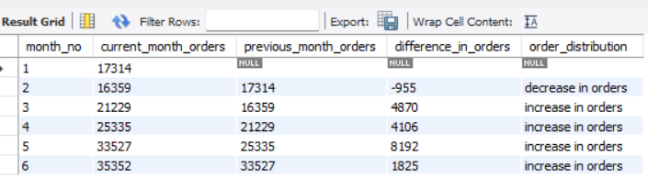

**Total quantity sold analysis:**

**calculate the total quantity sold for each respective month:**

select month(transaction_date), sum(transaction_qty) as quantity_sold from coffee_shop_sales

group by month(transaction_date) order by month(transaction_date);

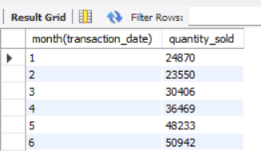

**calculate the total quantity sold for any particular month**

select month(transaction_date), sum(transaction_qty) as quantity_sold from coffee_shop_sales where month(transaction_date) = 4 group by month(transaction_date);

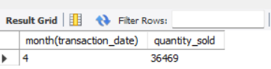

**Determine the month on month increase or decrease in the total quantity sold:**

**Calculate the difference in the total quantity sold between the selected month and the previous month:**

select month(transaction_date), sum(transaction_qty) as quantity_sold_current_month,

lag(sum(transaction_qty)) over(order by month(transaction_date)) as previous_month_quantity,

sum(transaction_qty) - lag(sum(transaction_qty)) over(order by month(transaction_date)) as difference_in_qty_sold,

case

when sum(transaction_qty) > lag(sum(transaction_qty)) over(order by month(transaction_date)) then 'increse in qty sold'

when sum(transaction_qty) < lag(sum(transaction_qty)) over(order by month(transaction_date)) then 'decrease in qty sold'

when sum(transaction_qty) = lag(sum(transaction_qty)) over(order by month(transaction_date)) then 'no change in qty sold'

end as qty_sold_distribution

from coffee_shop_sales

group by month(transaction_date) order by month(transaction_date);

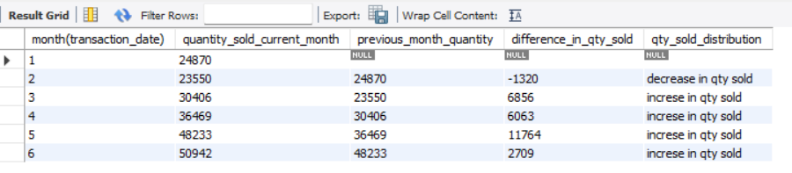

**daily sales, quantity and total order analysis by any given date**

select transaction_date, concat(round(sum(transaction_qty * unit_price)/1000,1),'K') as total_sales,

sum(transaction_qty) as total_qty_sold,

count(transaction_id) as total_orders from coffee_shop_sales where transaction_date = '2023-03-11';

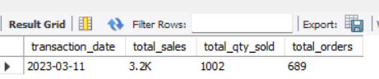

**Day by day SALES FOR a given month**

select day(transaction_date) as day_of_month, round(sum(unit_price * transaction_qty),1) as total_sales

from coffee_shop_sales where month(transaction_date) = 5 group by day(transaction_date) order by day(transaction_date);

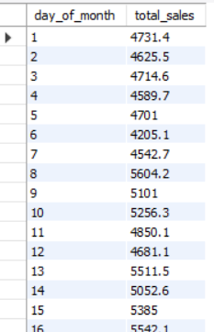 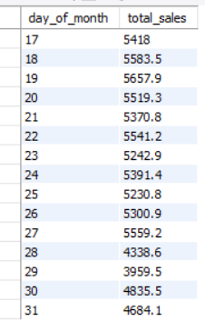

**SALES BY WEEKDAY / WEEKEND:**

select month(transaction_date) as monthNo,

case when dayofweek(transaction_date) in (1,7) then 'weekend'

else 'weekdays'

end as day_type,

concat(round(sum(unit_price * transaction_qty)/1000,1),'K') as total_sales from coffee_shop_sales

group by month(transaction_date), case when dayofweek(transaction_date) in (1,7) then 'weekend'

else 'weekdays'

end;

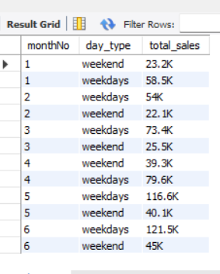

**sales by store location for all the months**

select store_location, month(transaction_date) as monthno, concat(round(sum(transaction_qty * unit_price)/1000,1),'K') as total_sales

from coffee_shop_sales group by store_location, month(transaction_date) order by sum(transaction_qty * unit_price) desc;

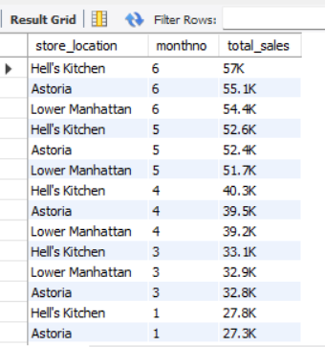

**sales by store location for a given month**

select store_location, concat(round(sum(transaction_qty * unit_price)/1000,1),'K') as total_sales

from coffee_shop_sales where month(transaction_date) =5 group by store_location order by sum(transaction_qty * unit_price) desc;

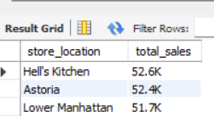

**Daily sales with average line:**

select month(transaction_date), avg(unit_price * transaction_qty) as avereage_sales

from coffee_shop_sales group by month(transaction_date);

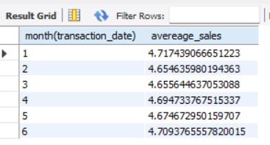

**comparing daily sales with average sales – if greater than “above average” and lesser than “below average”**

select day_of_month, total_sales, avg_sales,

case

when total_sales > avg_sales then "above average"

when total_sales < avg_sales then "below average"

else "equal to average"

end as sales_status from (

select date(transaction_date) as day_of_month, sum(transaction_qty * unit_price) as total_sales, avg(sum(transaction_qty * unit_price)) over()

as avg_sales from coffee_shop_sales where month(transaction_date) = 5 group by date(transaction_date)) as sales_data order by day_of_month

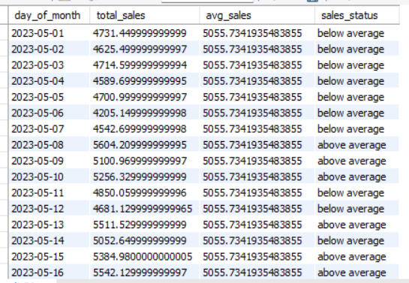 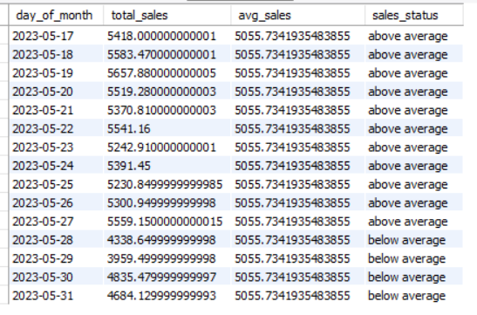

**Sales analysis by product category:**

select product_category, sum(transaction_qty * unit_price) as total_sales

from coffee_shop_sales group by product_category order by sum(transaction_qty * unit_price) desc;

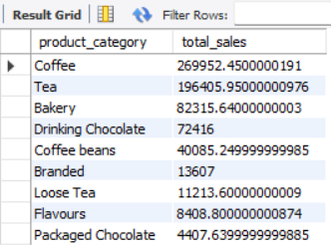

**Top 10 products by sales:**

select product_type, sum(transaction_qty * unit_price) as total_sales from coffee_shop_sales

group by product_type order by sum(transaction_qty * unit_price) desc limit 10

